Test Case ID: TC01

Test Case: Verify products are displayed

Test Steps: Open DemoBlaze home page.

Expected Result: Products should be displayed on the home page.

Actual Result: Products such as Samsung Galaxy S6, Nokia Lumia 1520 and Nexus 6 are displayed successfully.

Status: PASS

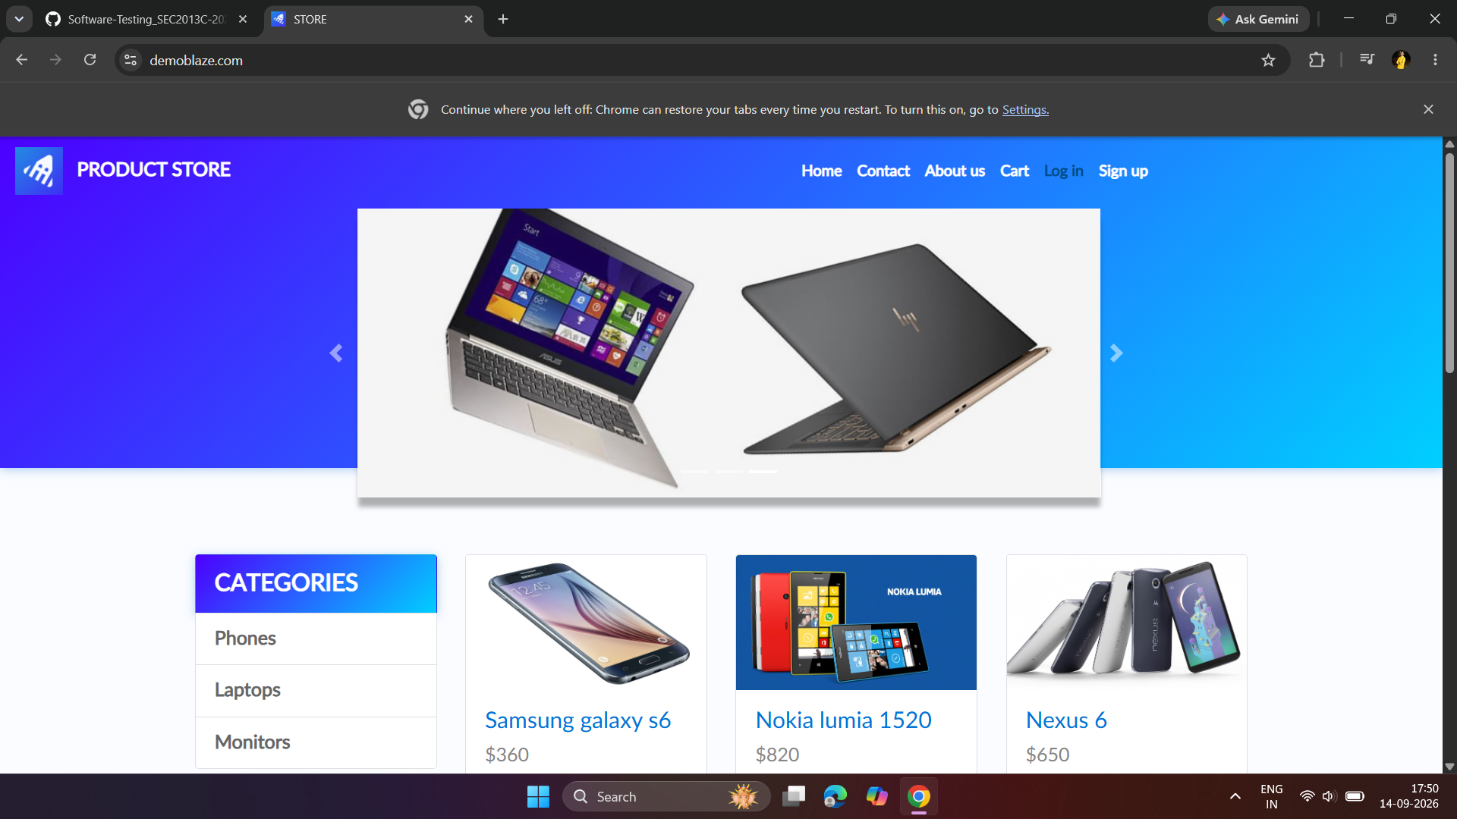

Test Case ID: TC02

Test Case: Verify product can be selected

Test Steps: Click on Samsung Galaxy S6 from the product list.

Expected Result: Selected product page should open.

Actual Result: Samsung Galaxy S6 product page opened successfully.

Status: PASS

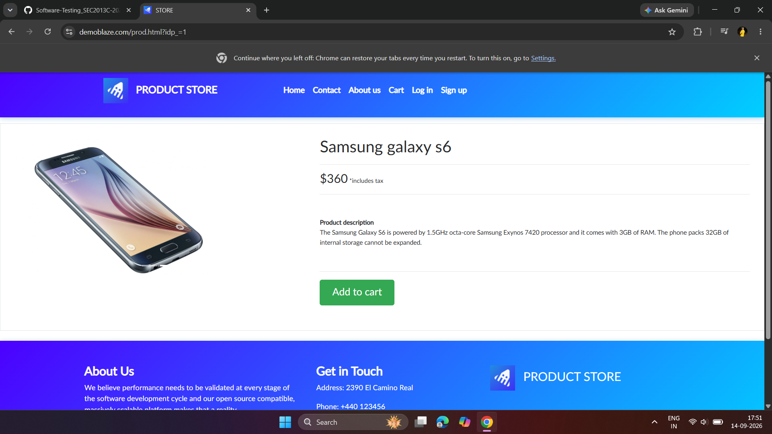

Test Case ID: TC03

Test Case: Verify product details are displayed

Test Steps: Open Samsung Galaxy S6 product page.

Expected Result: Product name, price and description should be displayed.

Actual Result: Product name, price ($360) and product description are displayed successfully.

Status: PASS

Test Case ID: TC04

Test Case: Verify product can be added to cart

Test Steps: Click Add to cart button.

Expected Result: Product should be added to cart successfully.

Actual Result: “Product added” message was displayed successfully.

Status: PASS

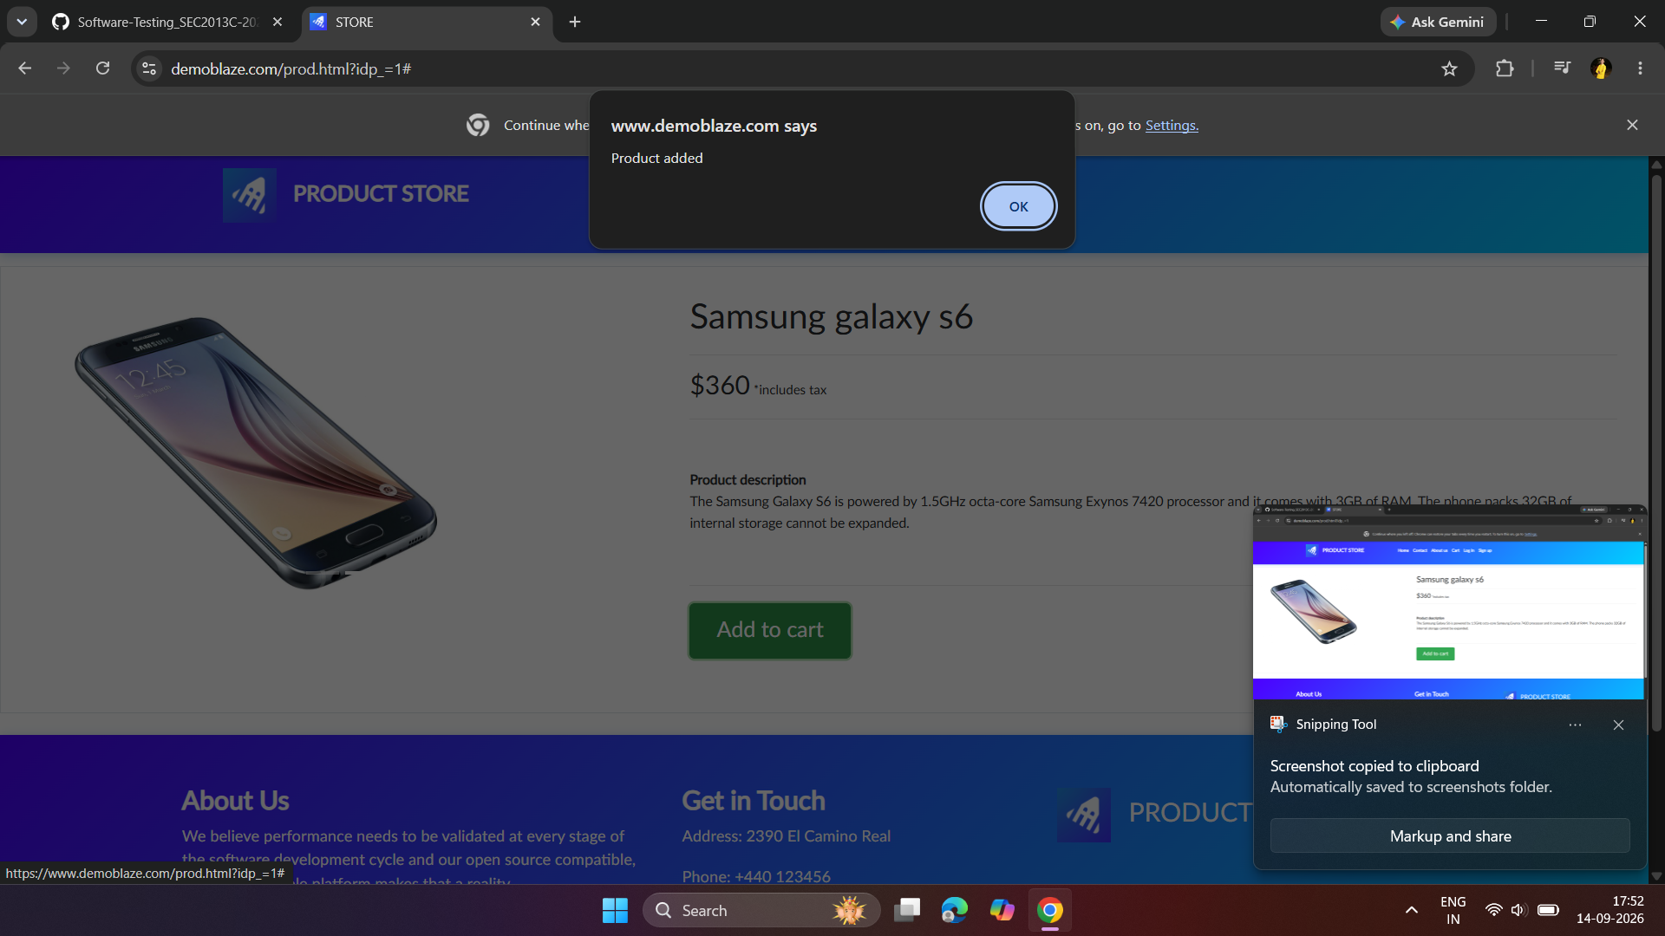

Test Case ID: TC05

Test Case: Verify cart can be opened

Test Steps: Click on Cart.

Expected Result: Cart page should open.

Actual Result: Cart page opened successfully.

Status: PASS

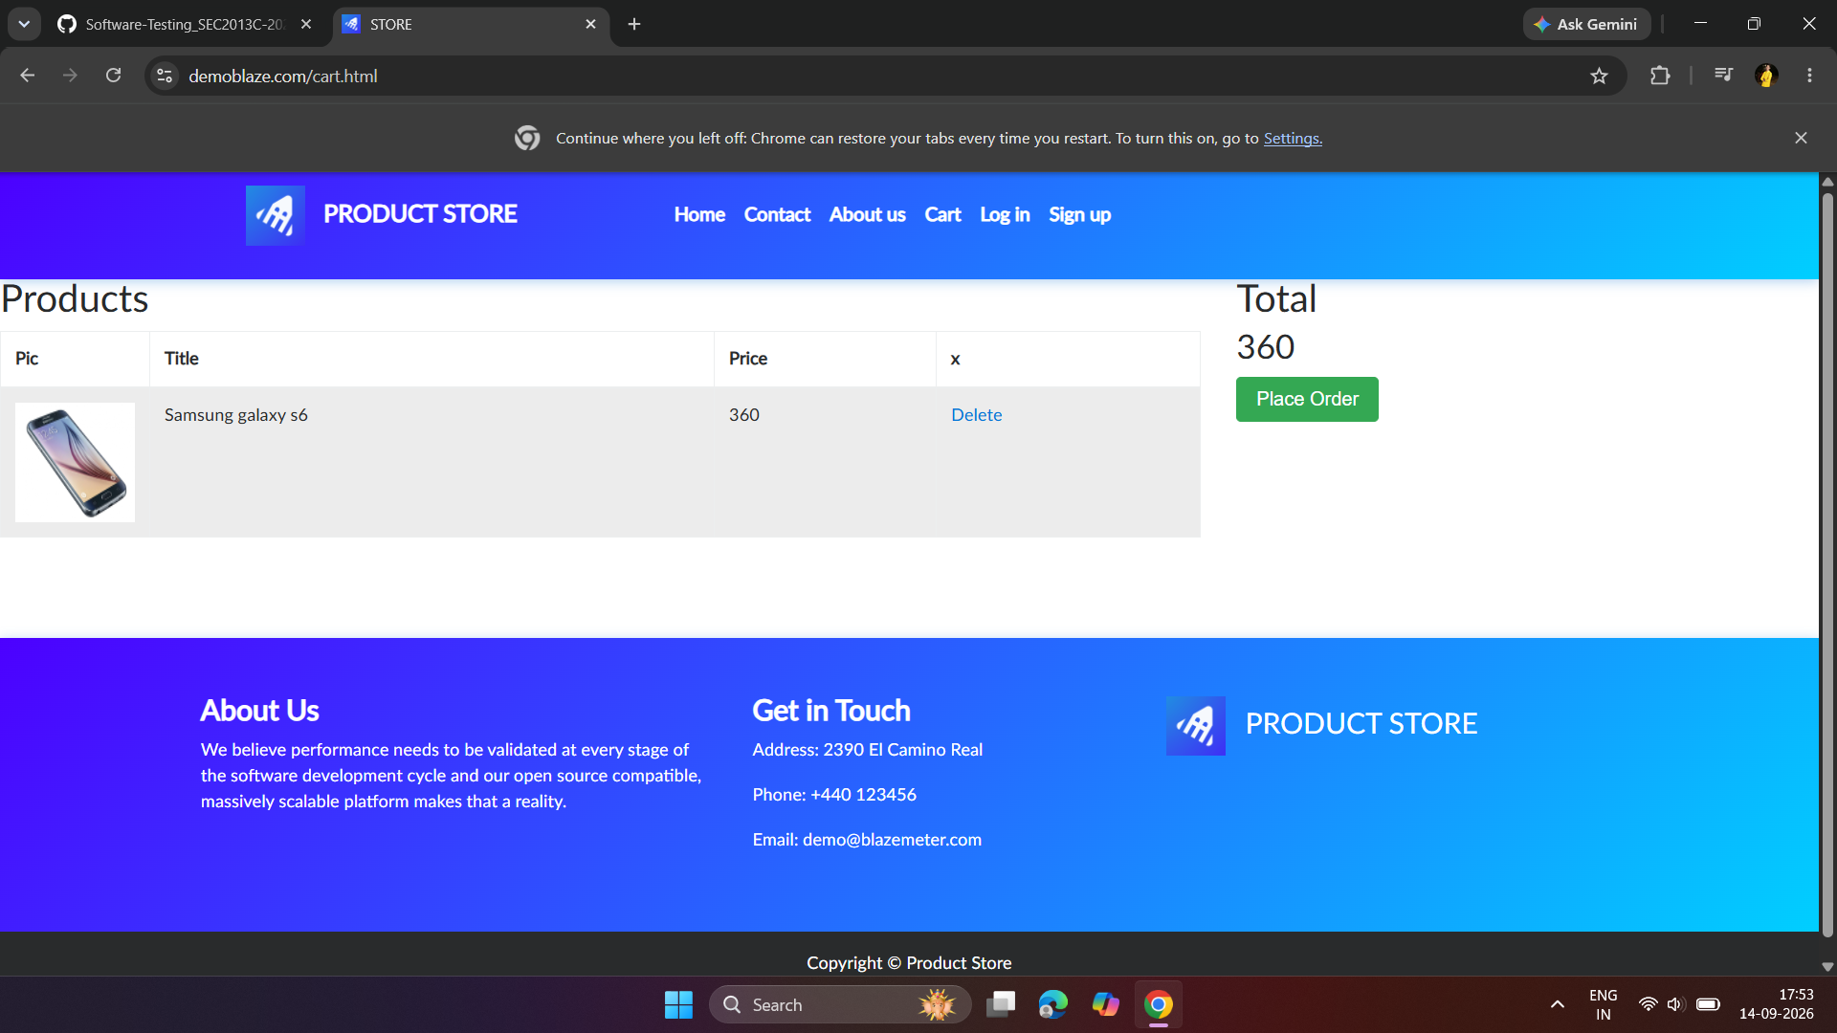

Test Case ID: TC06

Test Case: Verify added product appears in cart

Test Steps: Open Cart after adding Samsung Galaxy S6.

Expected Result: Samsung Galaxy S6 should be displayed in the cart with its price
.
Actual Result: Samsung Galaxy S6 is displayed in the cart with price 360 and total 360.

Status: PASS

Test Case ID: TC07

Test Case: Verify product can be removed from cart

Test Steps: Click Delete for Samsung Galaxy S6.

Expected Result: Product should be removed from the cart.

Actual Result: Samsung Galaxy S6 was successfully removed from the cart.

Status: PASS

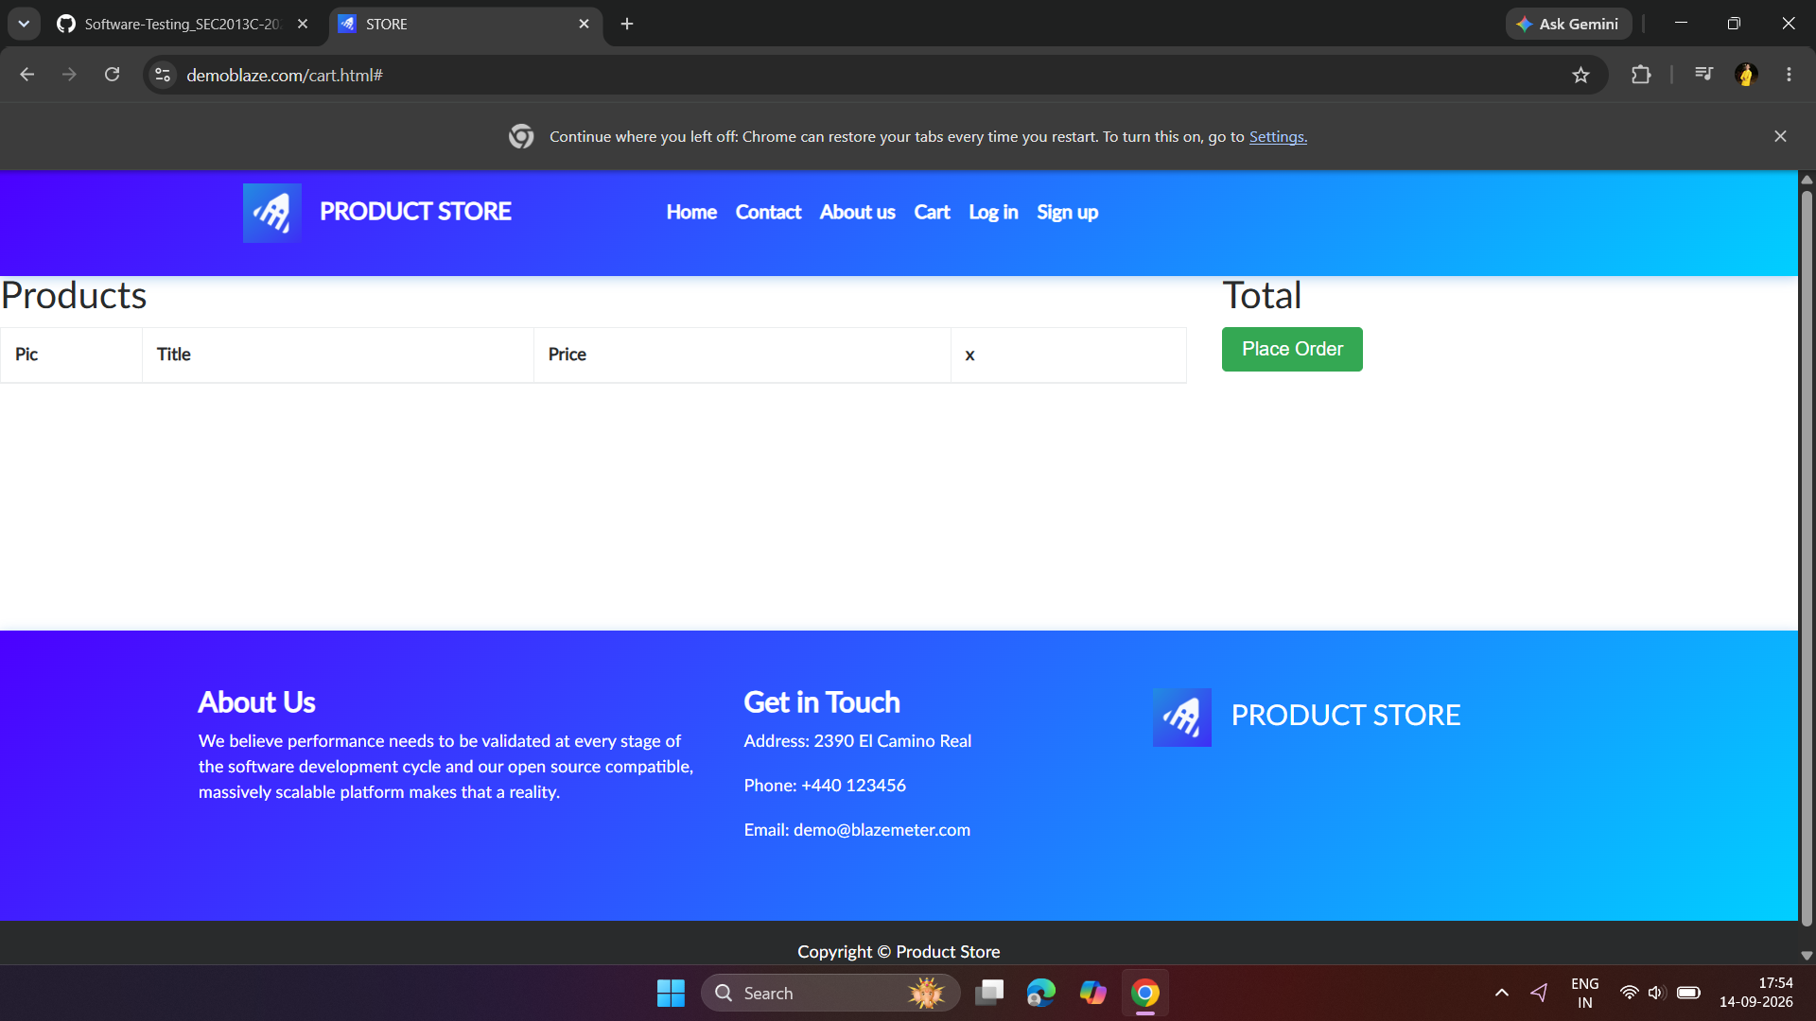

Test Case ID: TC08

Test Case: Verify cart becomes empty after product removal

Test Steps: Remove the product and check the cart.

Expected Result: Product should no longer be displayed in the cart.

Actual Result: Cart is empty and the removed product is no longer displayed.

Status: PASS

